# **Background**

# Pop-up floats are compact oceanographic instruments, designed for easy deployment. The pop-up floats sink to the seafloor and remain in place for an entire year, continuously recording bottom temperatures. At a pre-programmed date, a burn wire releases the float from its anchor and the float "pops up" to the surface, collecting data as it rises. Once at the surface, the float transmits all stored data via satellite back to the lab.

Your help in deploying Pop-up floats is greatly appreciated. Your deployment will play an important role in enabling researchers to understand the cold pool extent and other oceanographic features that influence fish, shellfish, and other parts of the Bering Sea shelf ecosystem.

# **Deployment**

1. Navigate to within 10 nautical miles of the target lat/long location
2. Double-check depth-- **depth at deployment must be less than 100 meters**
3. Slow vessel to 2kts-3kts and/or determined safe working speed
4. Record the float serial number (ex. 20##) on the Deployment Record sheet
5. Two people are needed: one to handle the float (30lbs) and one to handle the anchor (50lbs)
6. Carry the float by the metal frame, **the float cannot be dropped or withstand shock forces**
7. Do not grab the black cable and be cautious that it doesn’t get snagged or pulled
8. **You can deploy off the side, or use slip lines to control a slide down the trawl ramp. Please make sure you have positive control of both the float and the anchor to minimize impacts to the float**
9. Pass one slip line through the anchor and another slip line through the float frame [Photos 1 & 2]
10. Work in tandem to gently lower the float and the anchor to the waterline [Photo 3]
11. Let the line slip through the float frame; the float will be floating at the surface [Photo 4]
12. Allow the float to stream out, maintain positive control of anchor [Photo 5]
13. Once the float and anchor cable are streaming out straight from the anchor, let slip the line to the anchor [Photo 6]
14. Mark deployment location and time: complete all info on Deployment Record sheet

**Follow up**

1. Email the Deployment Record info (emailing a photo of the filled-in page would be ideal) to contacts listed below, or use the provided envelope to send the deployment record via US Mail
2. If convenient, please take a posed photo of the crew doing the deployment together with the Pop-up float, and an action photo during the deployment would be a bonus if a third person is available — email any photos to both contacts listed below

**Contacts**

Sarah Donohoe, email sarah.s.donohoe@noaa.gov, cell phone 907-209-6978

Tom Van Pelt, email tvanpelt@uw.edu, cell phone 907-242-7725

Photos:

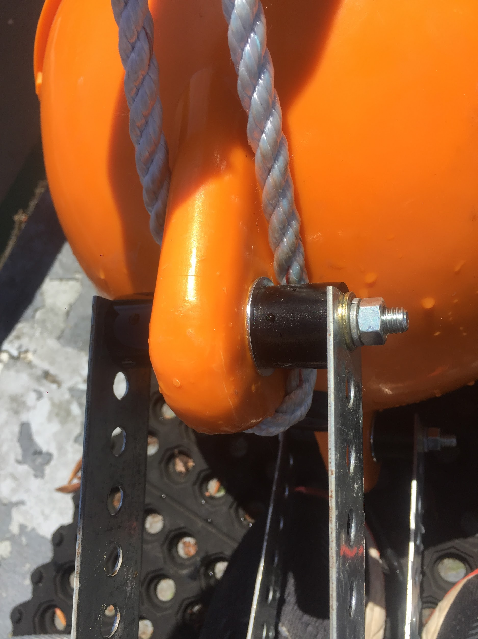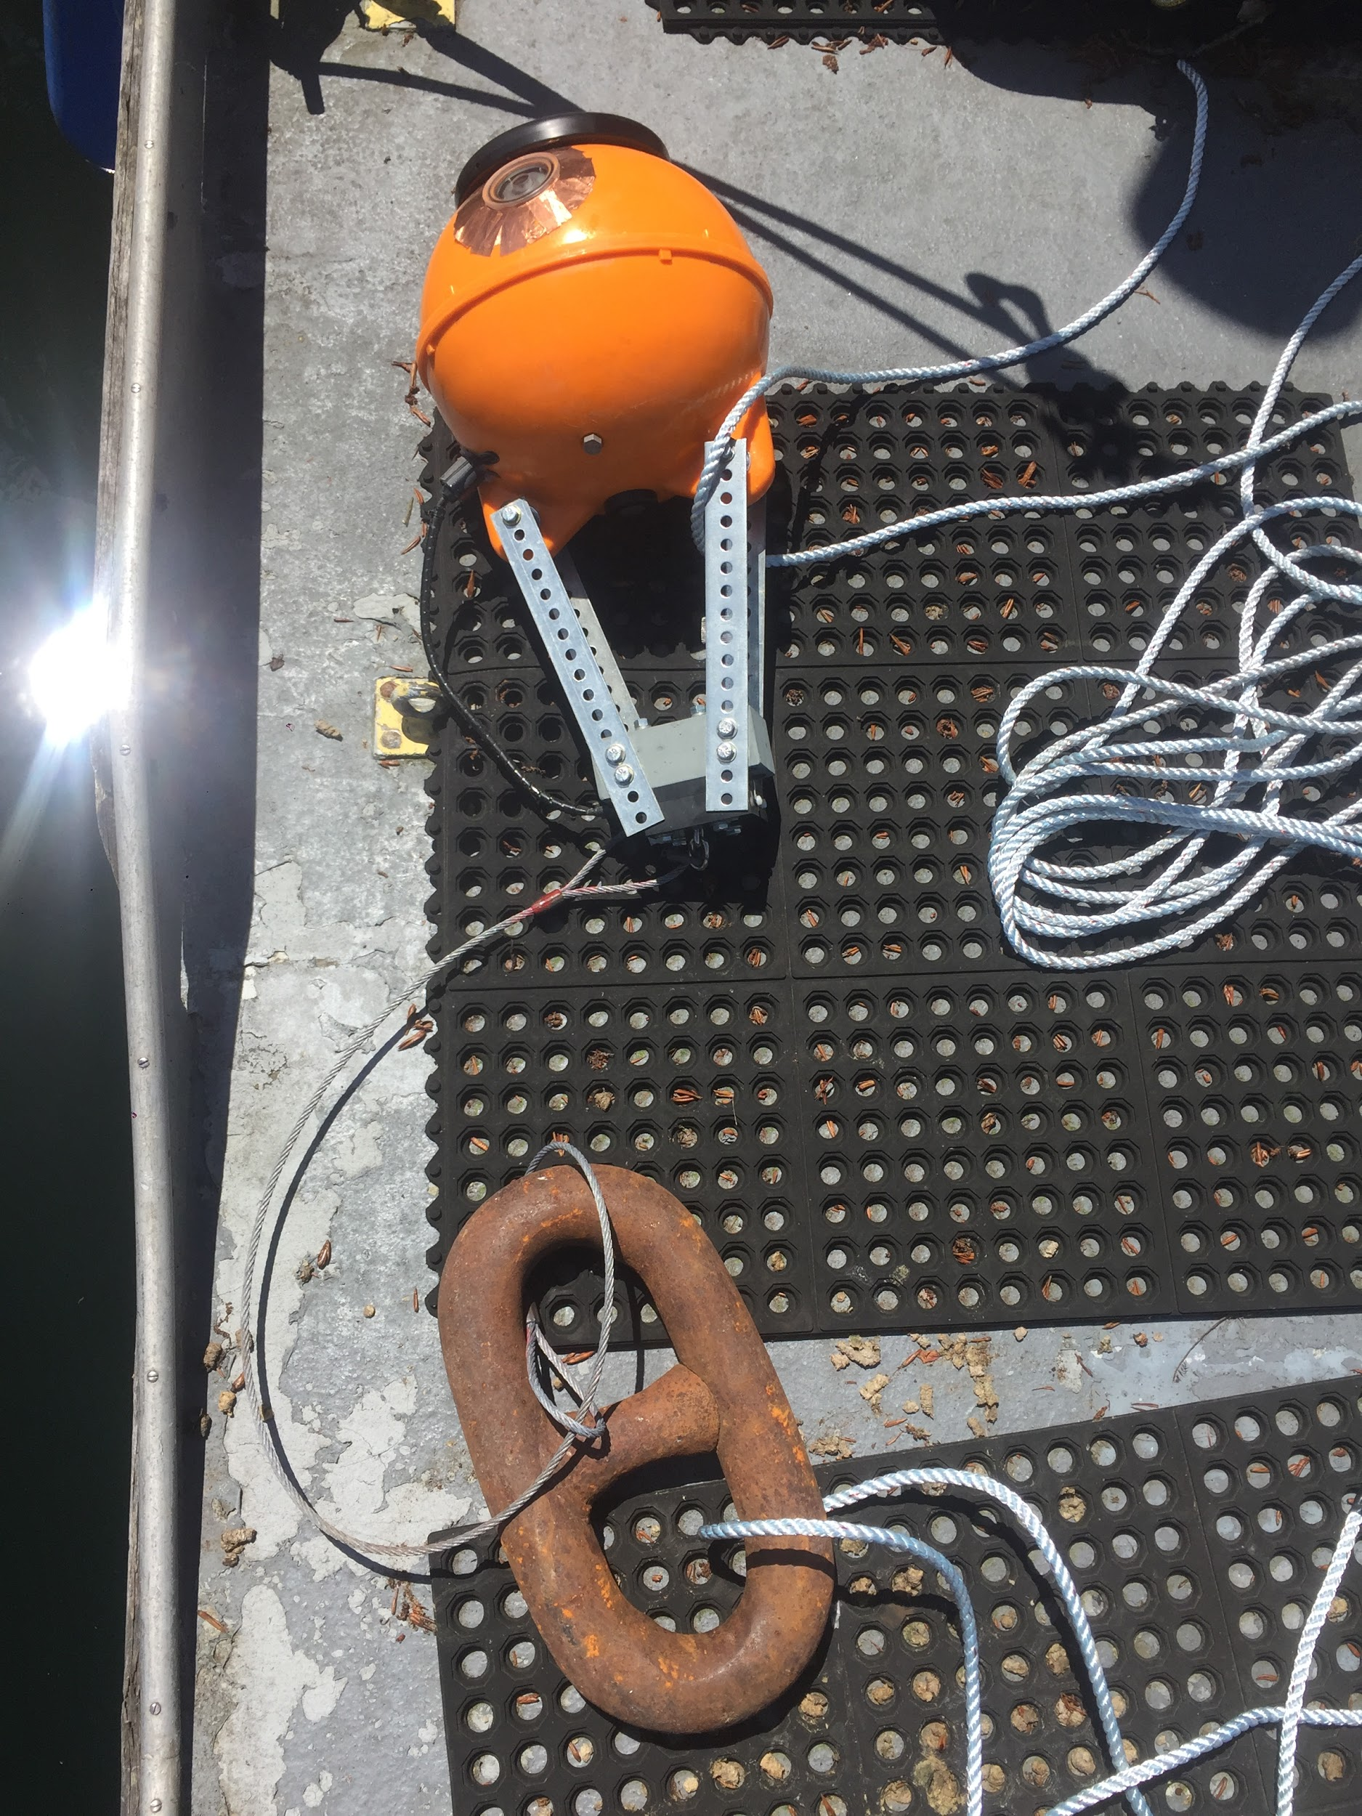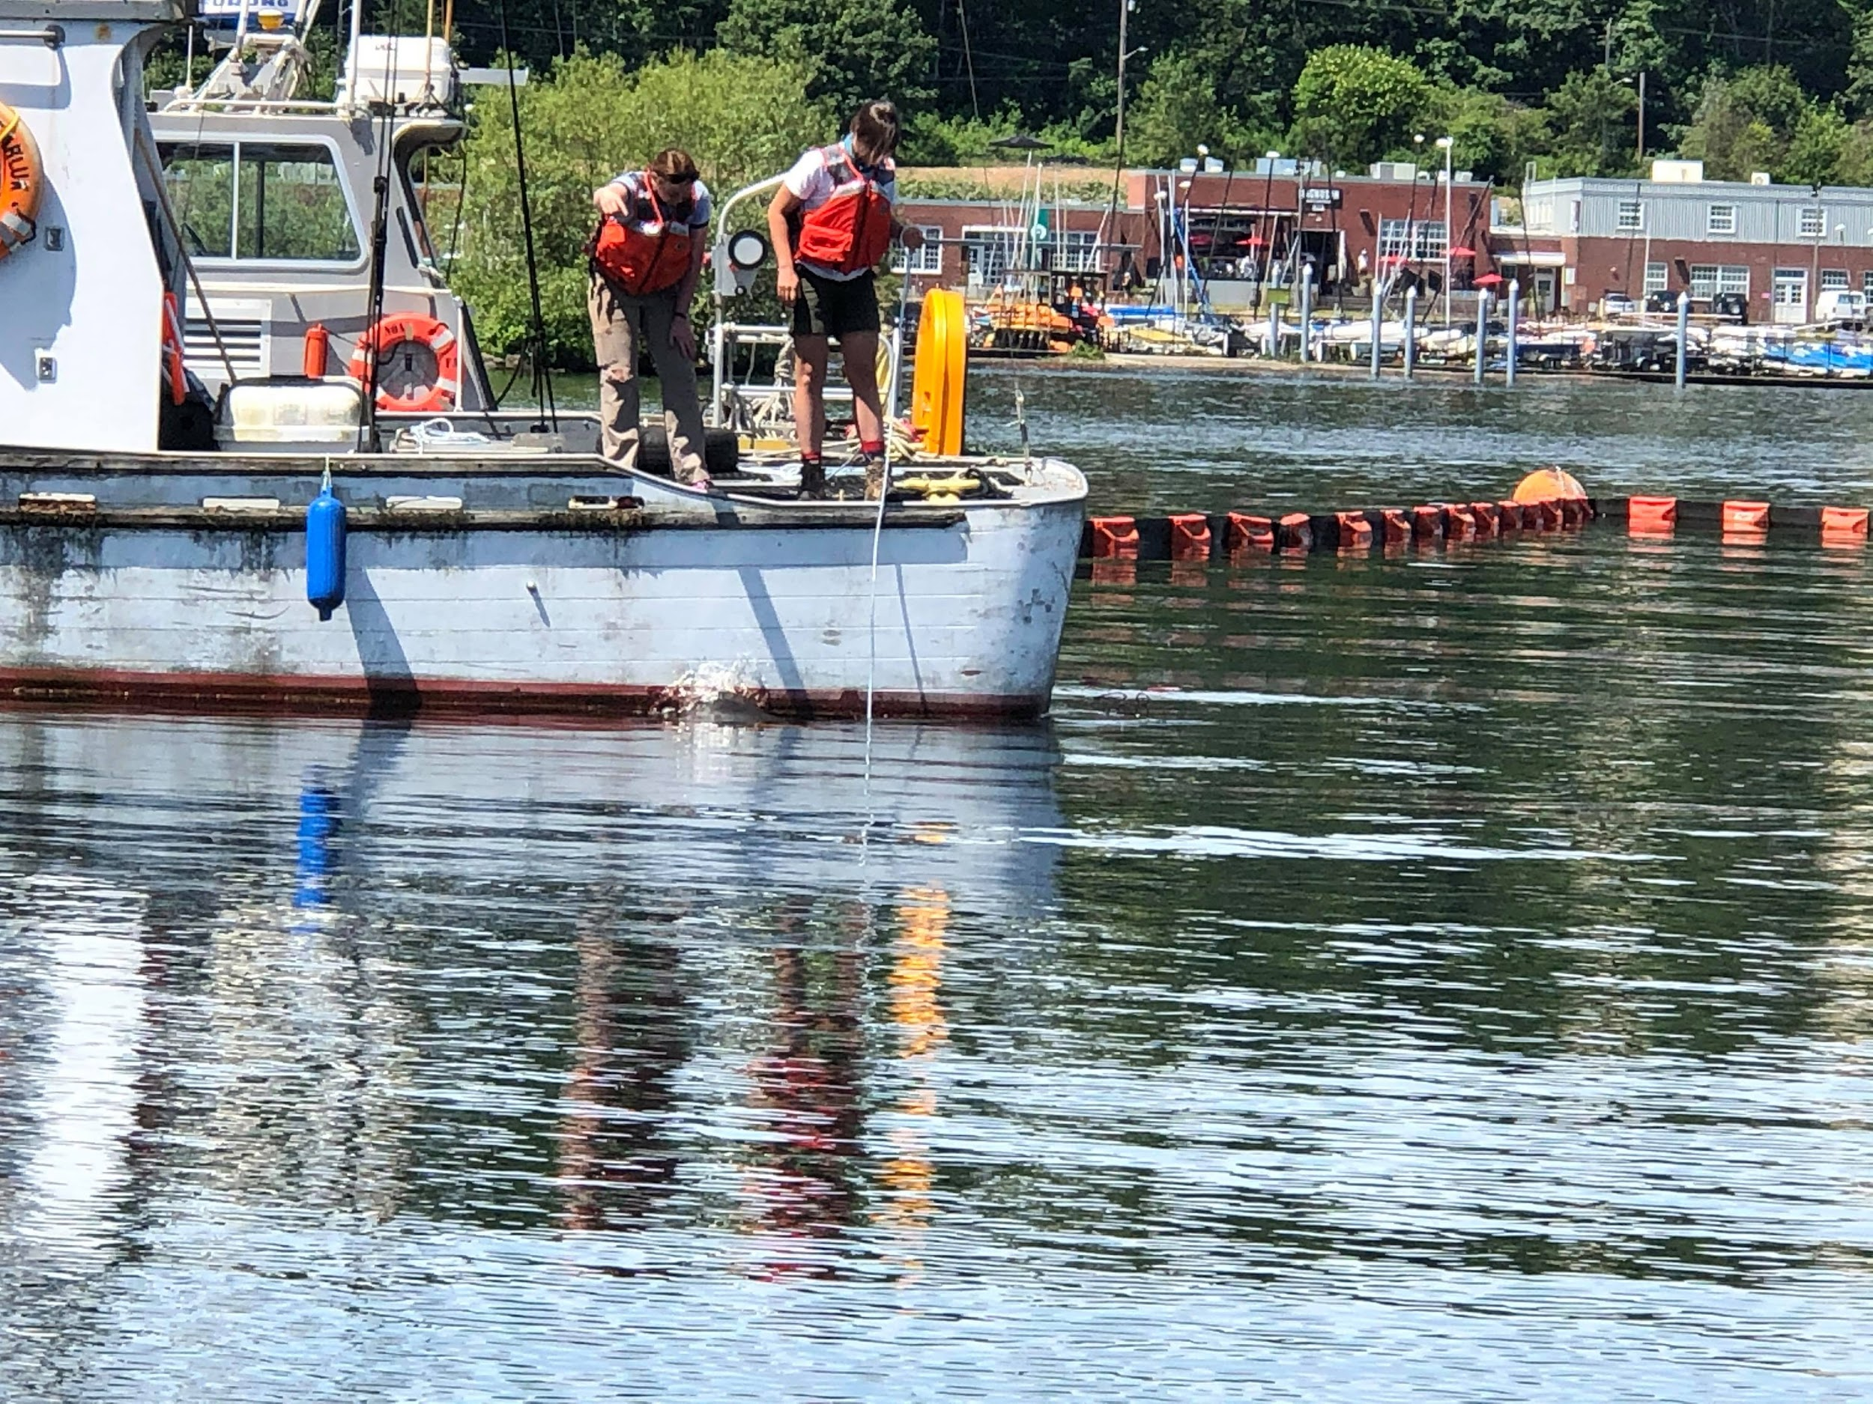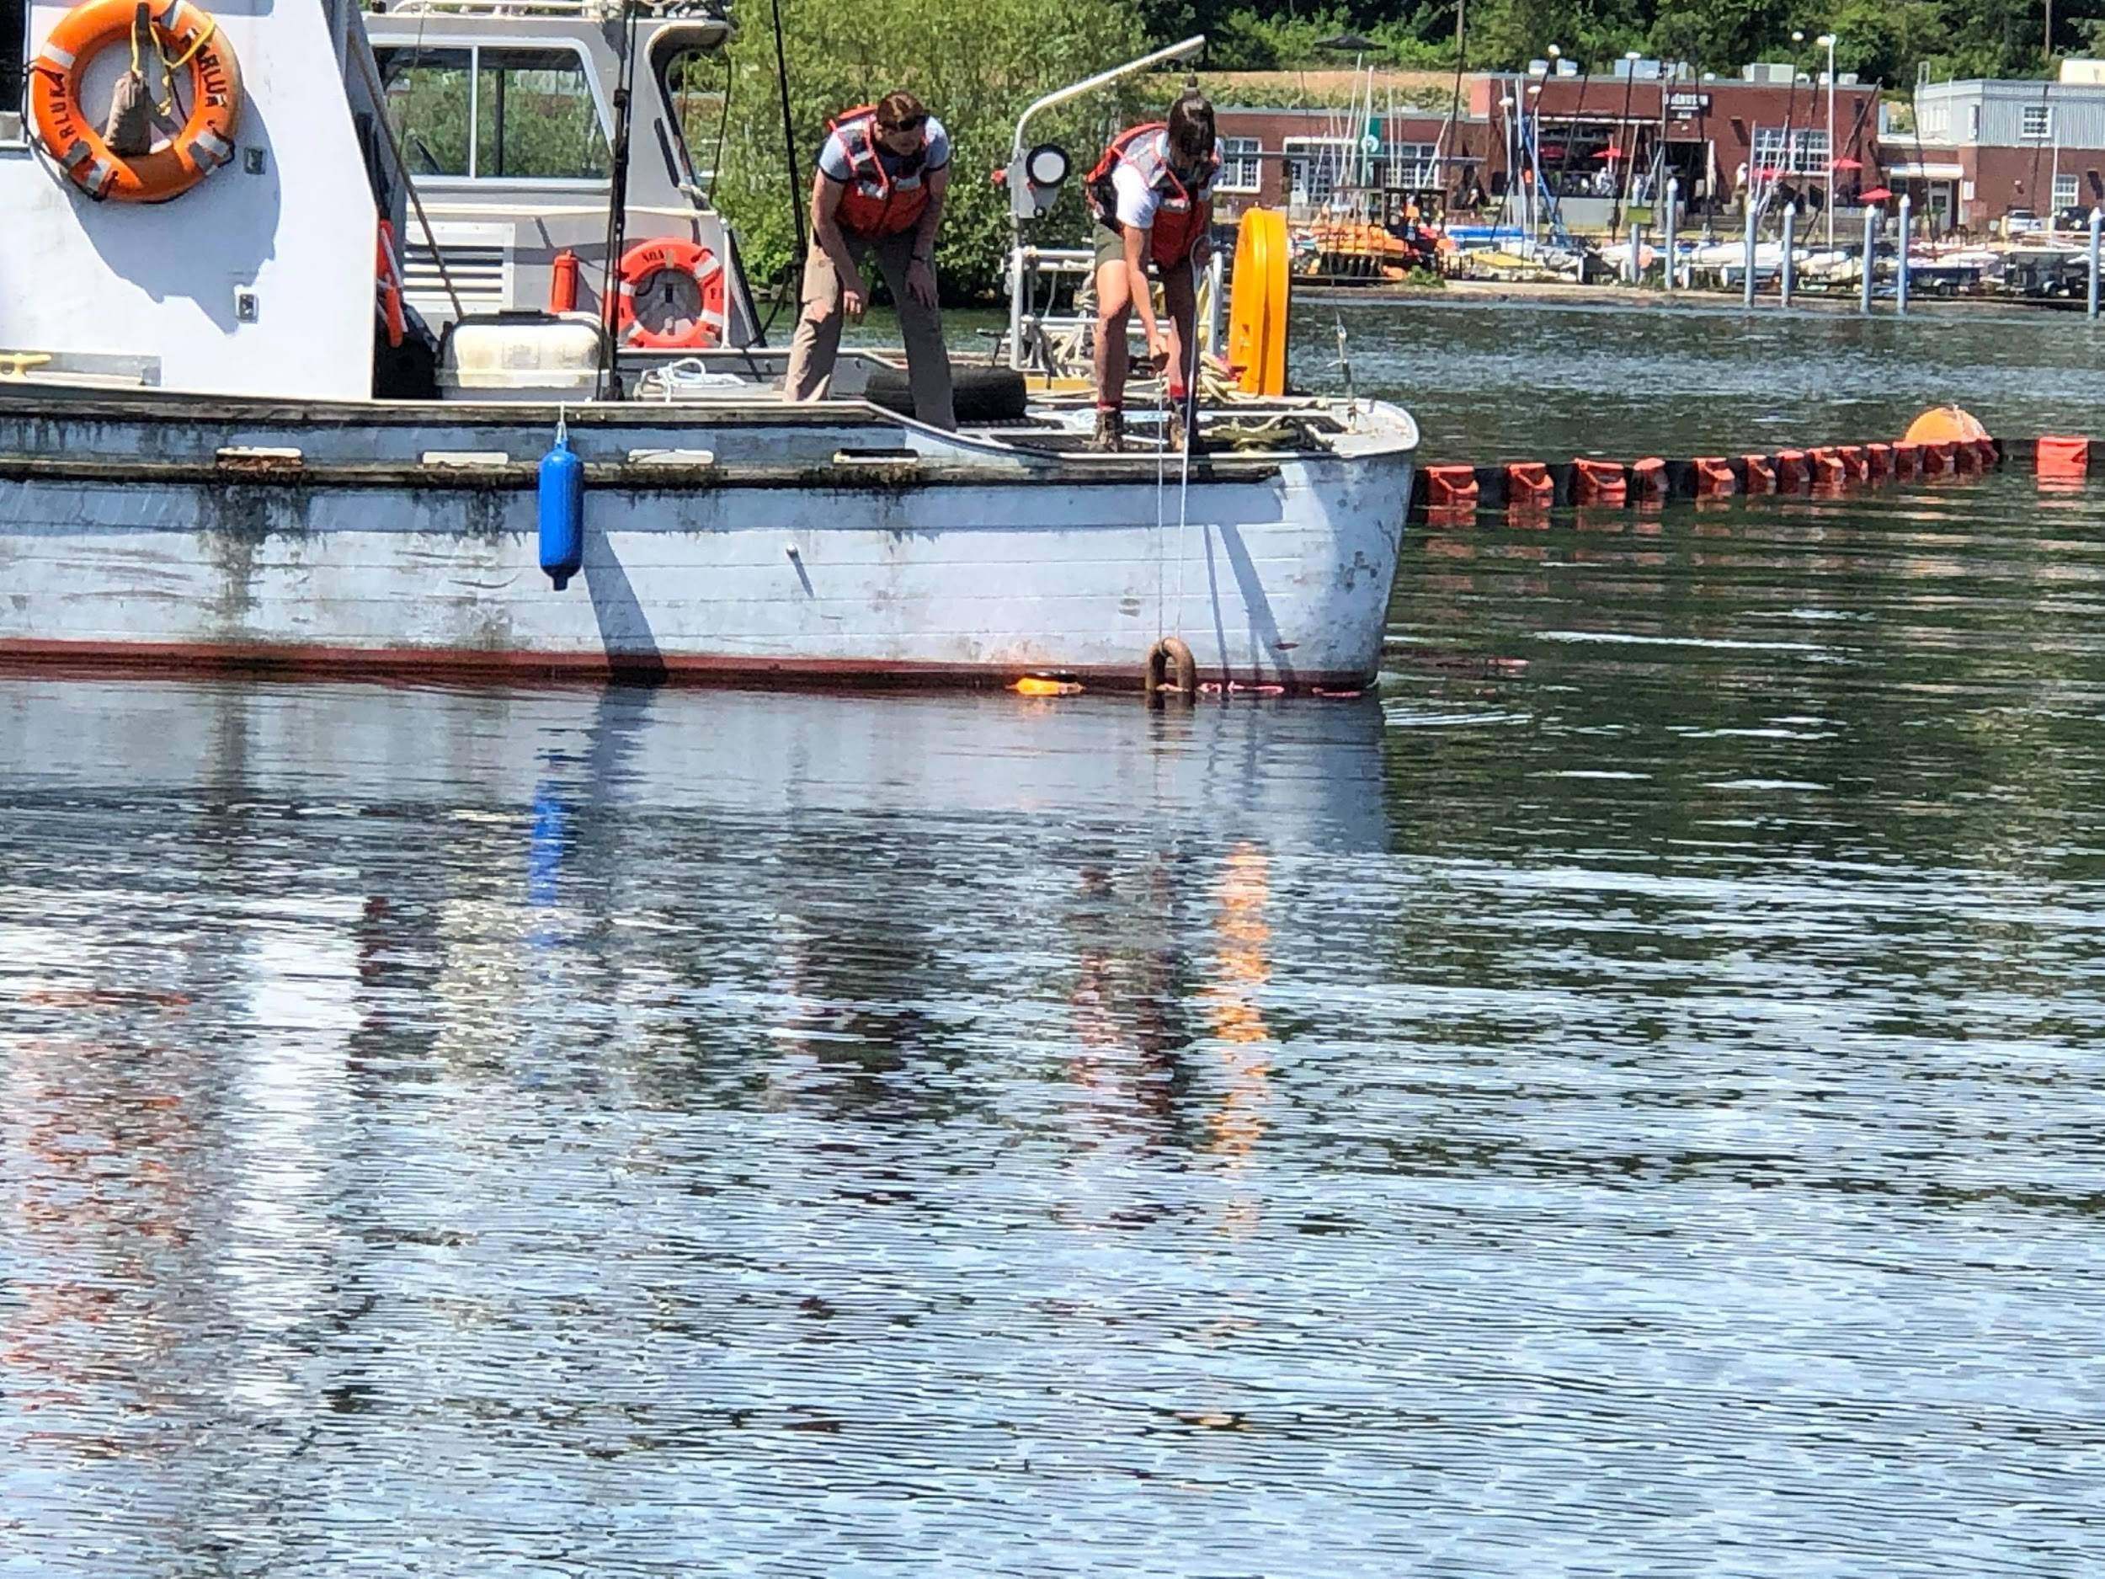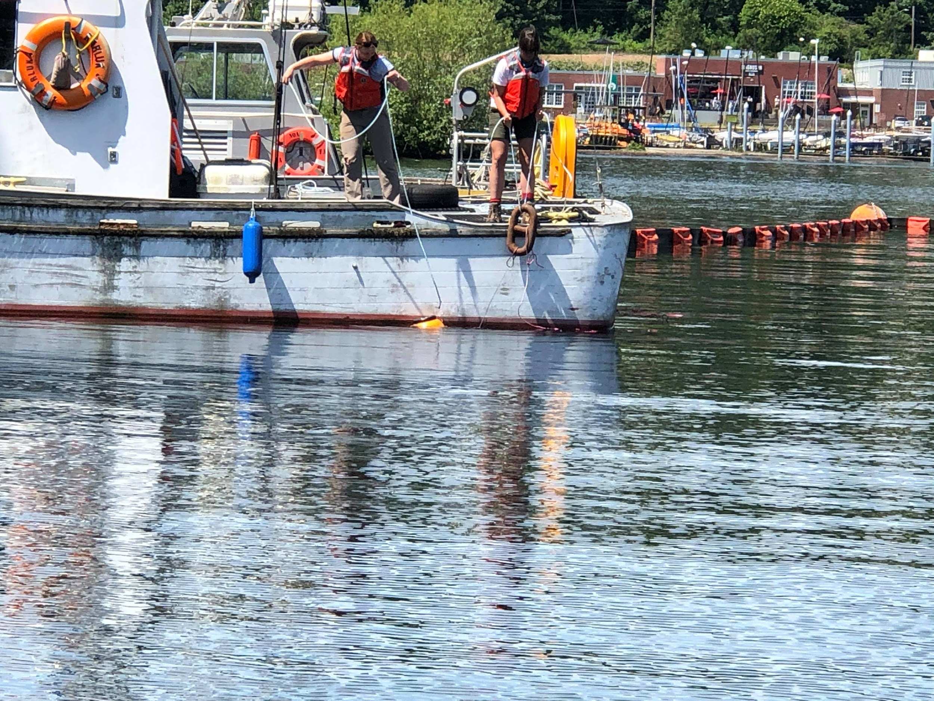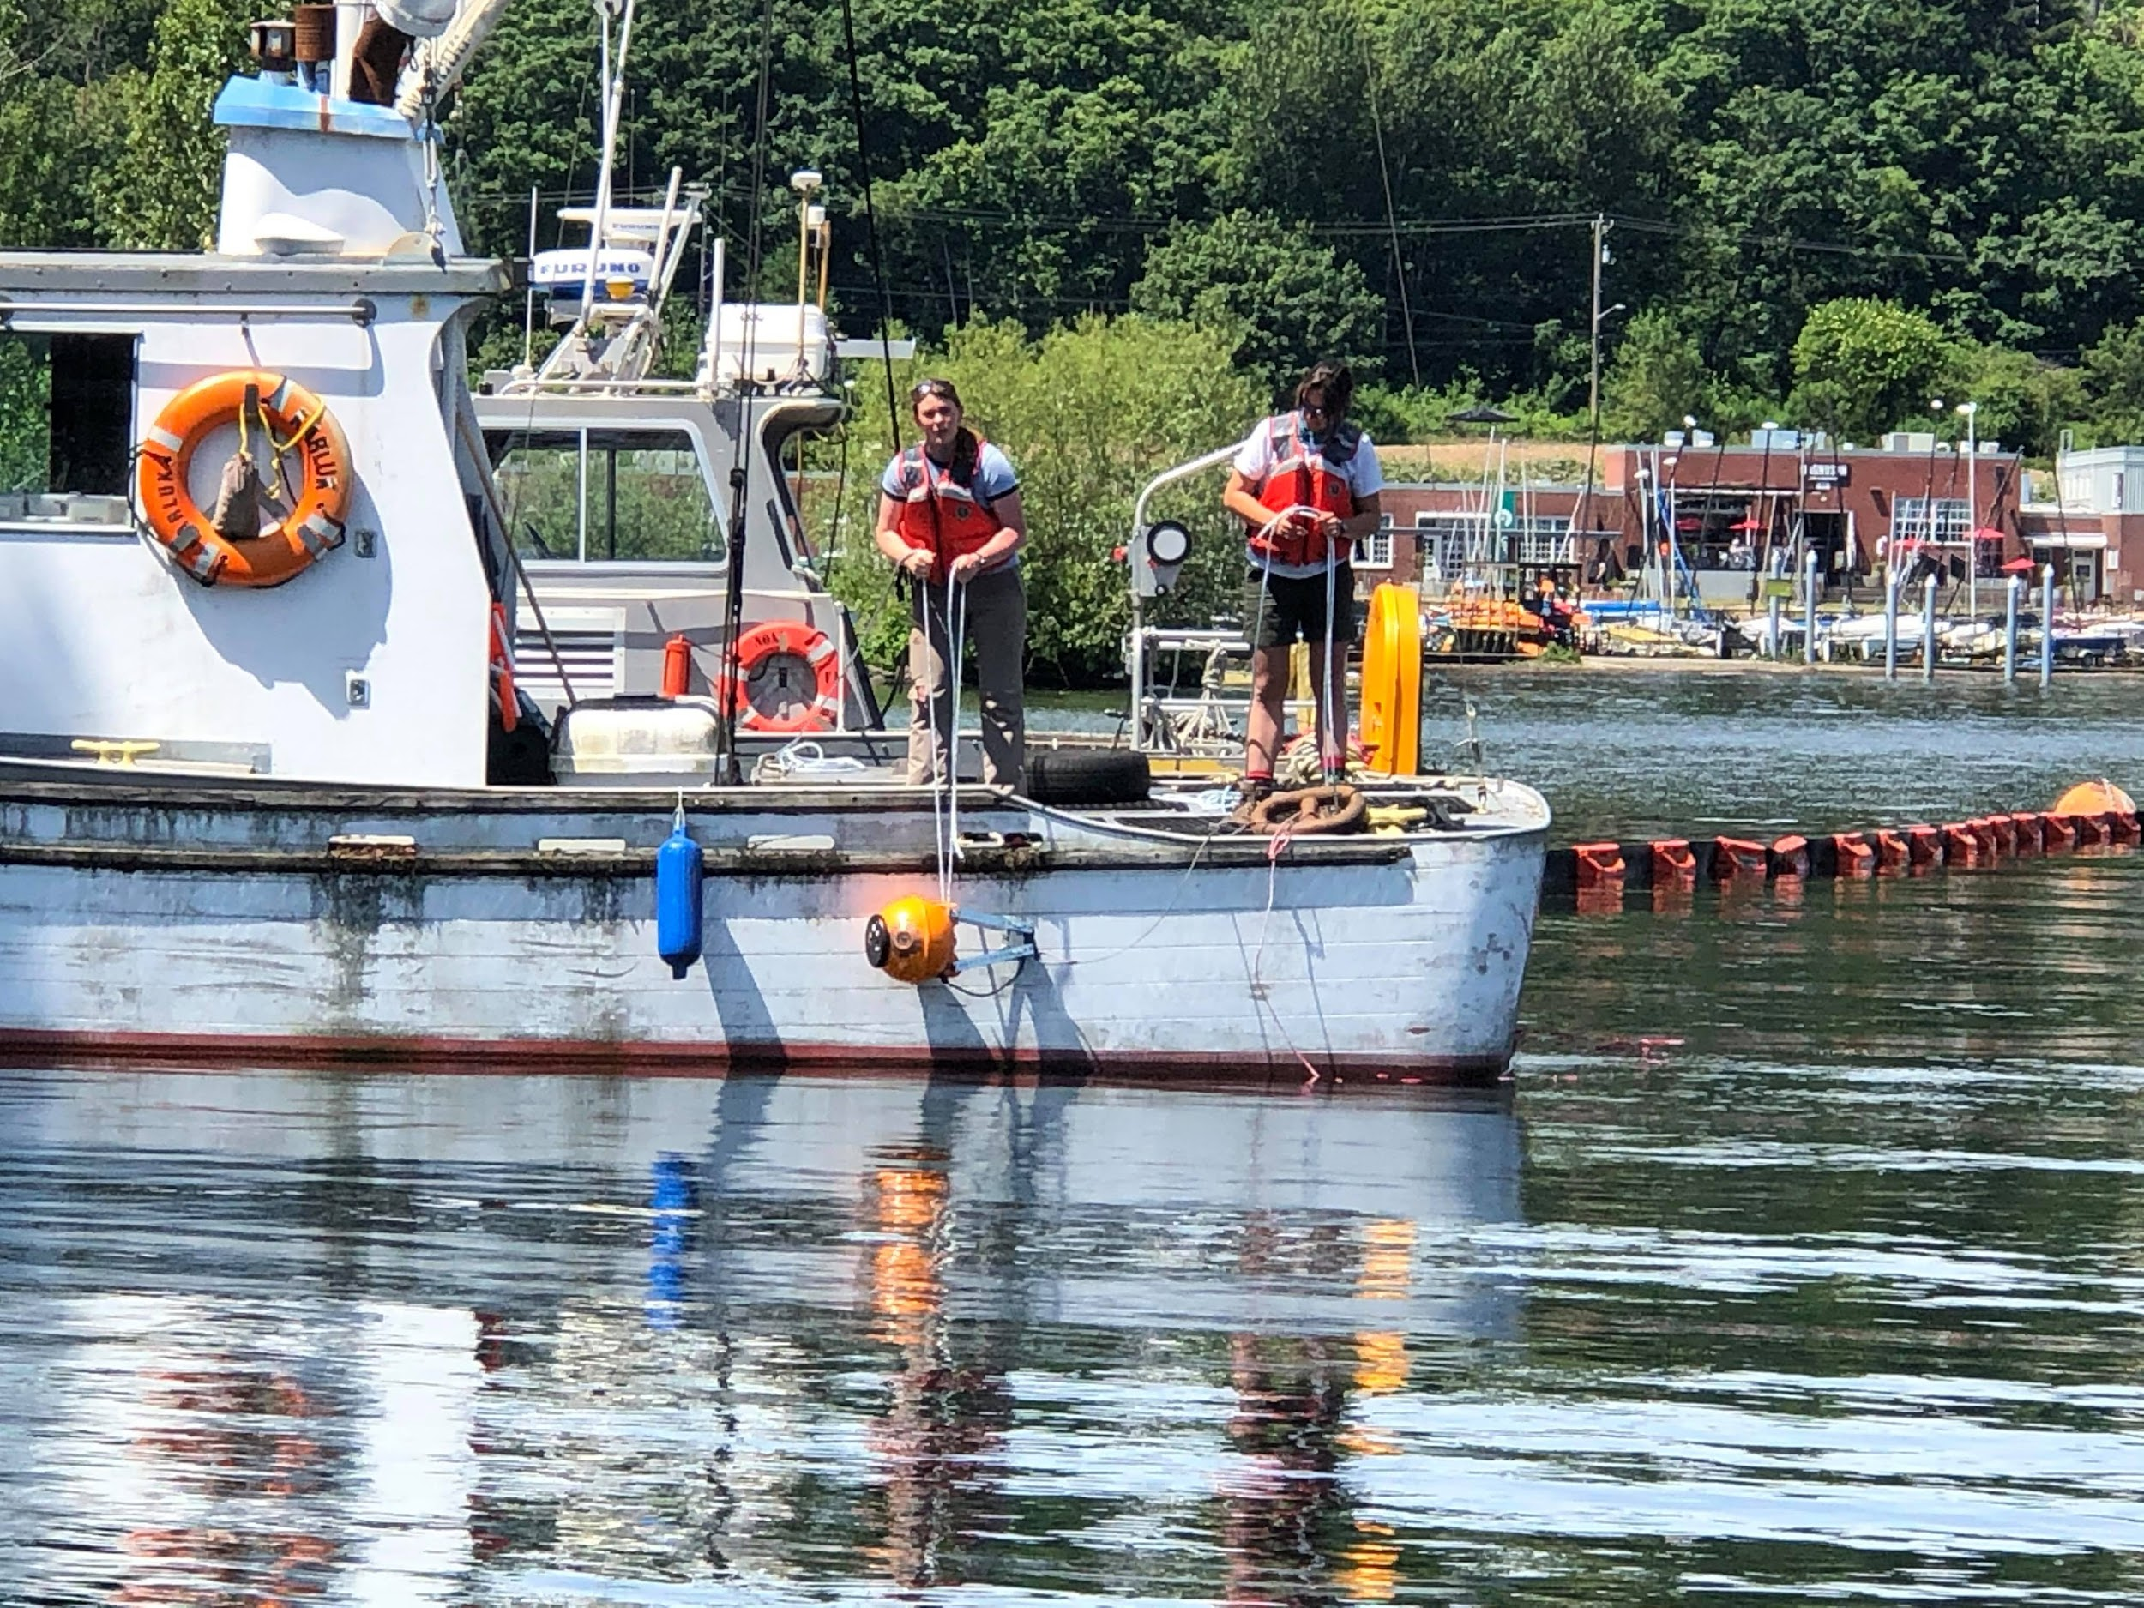

1.

2..

3.

4.

5.

6.

..

Slip line

Slip line

Caution! Do not pull or snag the black cable